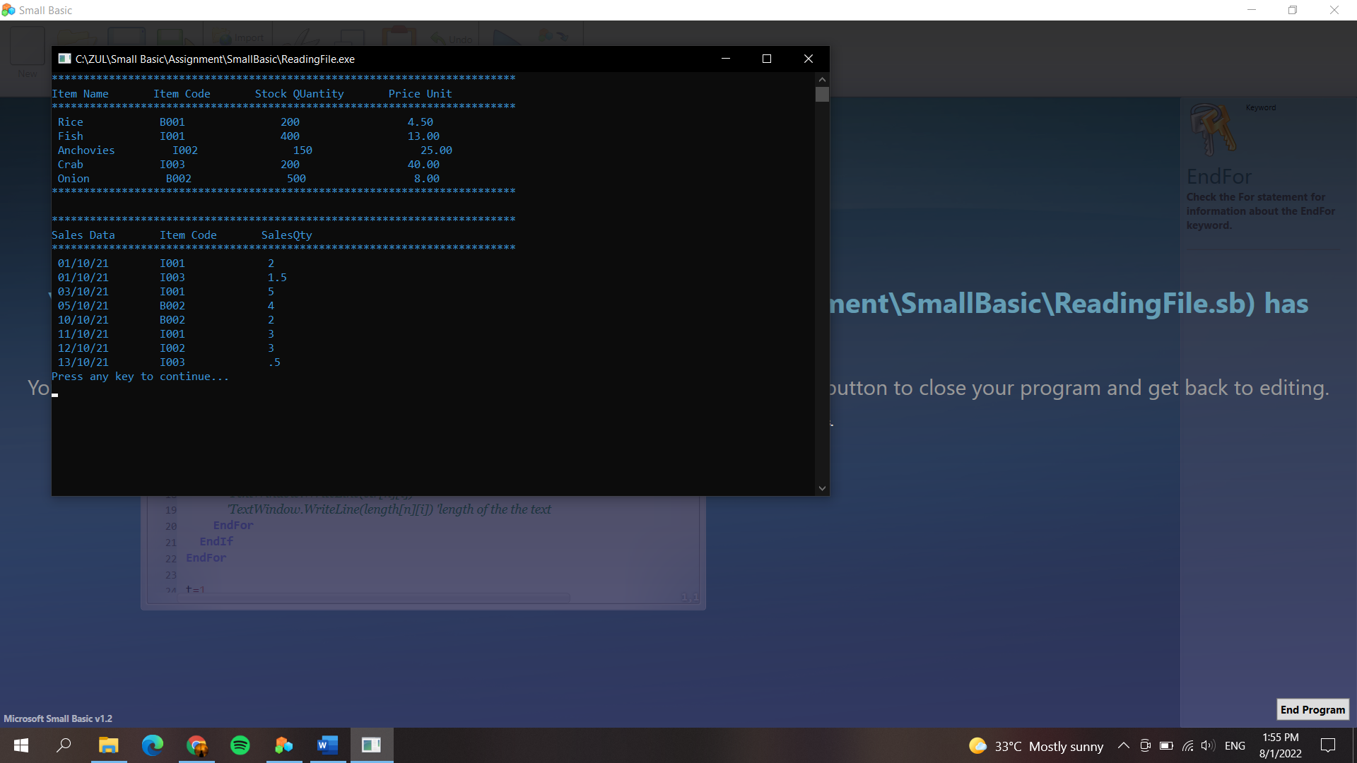

*'Author : Muhammad Zulhilmi Bin Rosli*

*'No. Matric : S61807*

TextWindow.ForegroundColor="darkcyan"

**For** n=1 **To** 2 *'repeat 2 times for 2 differents file*

**If** n=1 **Then**

**For** i = 1 **To** 5

str[n][i]=file.ReadLine("C:\\ZUL\\Small Basic\\Assignment\\SmallBasic\\itemdata.txt",i)

length[n][i]=Text.GetLength(str[n][i])

*'TextWindow.WriteLine(str[n][i])*

*'TextWindow.WriteLine(length[n][i]) 'length of the the text*

**EndFor**

**Else**

**For** i=1 **To** 8

str[n][i]=file.ReadLine("C:\\ZUL\\Small Basic\\Assignment\\SmallBasic\\salesdata.txt",i)

length[n][i]=Text.GetLength(str[n][i])

*'TextWindow.WriteLine(str[n][i])*

*'TextWindow.WriteLine(length[n][i]) 'length of the the text*

**EndFor**

**EndIf**

**EndFor**

t=1

**For** n=1 **To** 2

**If** n=1 **Then**

**For** i=1 **to** 5

**For** j=1 **To** length[n][i]

char=Text.GetSubText(str[n][i],j,1)

code=text.GetCharacterCode(char)

*'TextWindow.WriteLine(char+" has a code of " +code) 'nak tahu nilai code in character*

**If** j=length[n][i] **then**

line=Text.Append(line,char)

linesp[t]=line

t=t+1

line=""

**EndIf**

**If** code<> 44 And j<>length[n][i] **then**

line=text.Append(line,char)

**ElseIf** code=44 **then**

**If** Text.GetLength(line)<=7 **then**

line=line+" "

**EndIf**

linesp[t]=line

line=""

t=t+1

**EndIf**

**endfor**

**endfor**

*'TextWindow.WriteLine(" ")*

**Else**

t=1

**For** i=1 **To** 8

**For** j=1 **To** length[n][i]

char=text.GetSubText(str[n][i],j,1)

code=Text.GetCharacterCode(char)

**If** j=length[n][i] **Then**

line=text.Append(line,char)

linesp1[t]=line

line=""

t=t+1

**EndIf**

**If** code<>44 And j<>length[n][i] **Then**

line = Text.Append(line,char)

**ElseIf** code=44 **then**

linesp1[t]=line

line=""

t=t+1

**EndIf**

**EndFor**

**EndFor**

**EndIf**

**EndFor**

*'TextWindow.WriteLine(" ")*

counter=1

**For** t=1 **To** 5

**For** k=1 **To** 4

**If** k=1 **Then**

str[t]["ItemNo"]=linesp[counter]

**ElseIf** k=2 **then**

str[t]["ItemCode"]=linesp[counter]

**elseif** k=3 **Then**

str[t]["StockQty"]=linesp[counter]

**ElseIf** k=4 **then**

str[t]["PriceUnit"]=linesp[counter]

**EndIf**

counter=counter+1

**EndFor**

**EndFor**

TextWindow.WriteLine("*************************************************************************")

TextWindow.WriteLine("Item Name Item Code Stock QUantity Price Unit")

TextWindow.WriteLine("*************************************************************************")

**For** t=1 **To** 5

TextWindow.WriteLine(" "+str[t]["ItemNo"]+" "+str[t]["ItemCode"]+" "+str[t]["StockQty"]+" "+str[t]["PriceUnit"])

**EndFor**

TextWindow.WriteLine("*************************************************************************")

TextWindow.WriteLine(" ")

flag=1

**For** t=1 **To** 8

**For** k=1 **To** 3

**if** k=1 **Then**

str[t]["SalesDate"]=linesp1[flag]

**ElseIf** k=2 **then**

str[t]["ItemCode"]=linesp1[flag]

**ElseIf** k=3 **then**

str[t]["SalesQty"]=linesp1[flag]

**EndIf**

flag=flag+1

**EndFor**

**EndFor**

TextWindow.WriteLine("*************************************************************************")

TextWindow.WriteLine("Sales Data Item Code SalesQty ")

TextWindow.WriteLine("*************************************************************************")

**For** t=1 **To** 8

TextWindow.WriteLine(" "+str[t]["SalesDate"]+" "+str[t]["ItemCode"]+" "+str[t]["SalesQty"])

**EndFor**